**The Ark Documentation.**

**Add new subject: contact information.**

Once you have created a new subject you can add contact information.

To enter a phone contact number, click the Phone function.

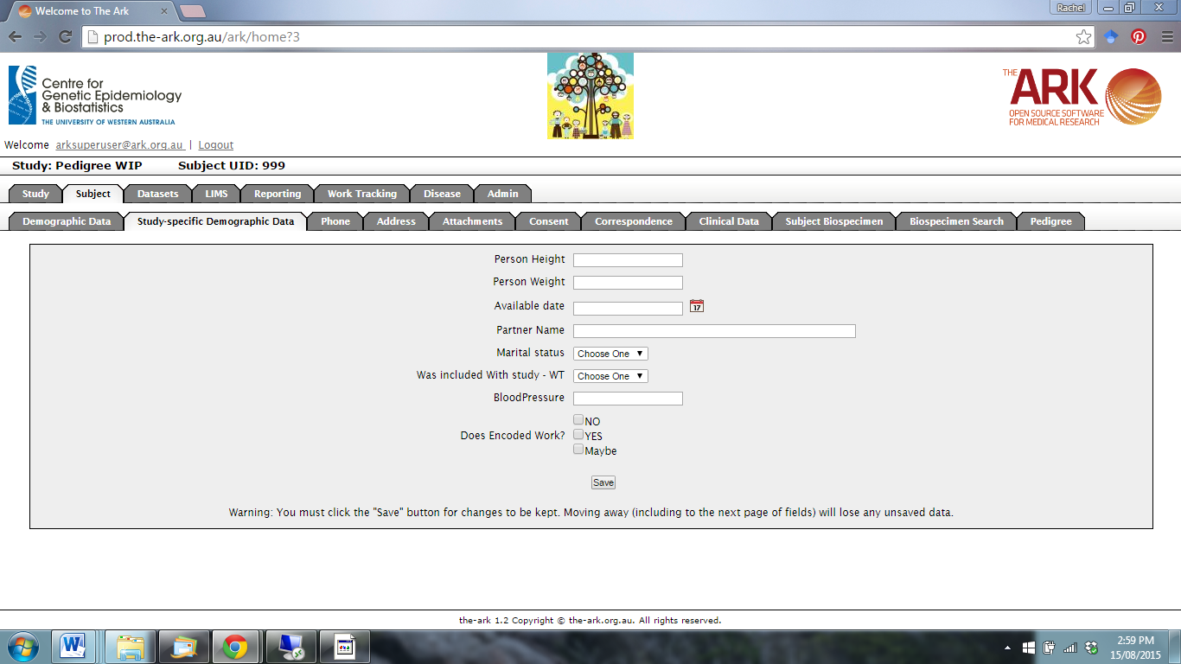

The following page will appear. Click new.

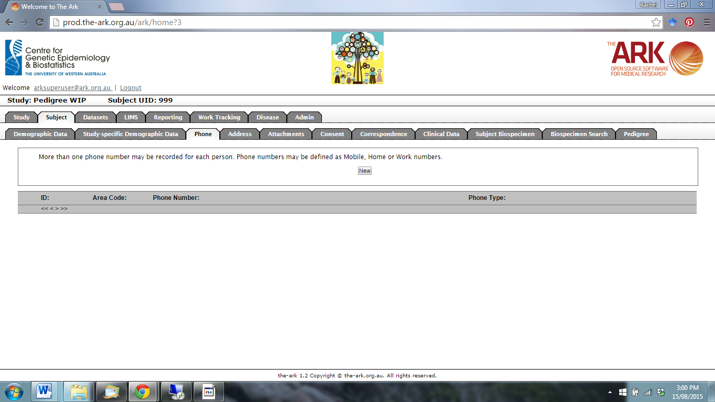

Enter the subject’s phone contact details and click save.

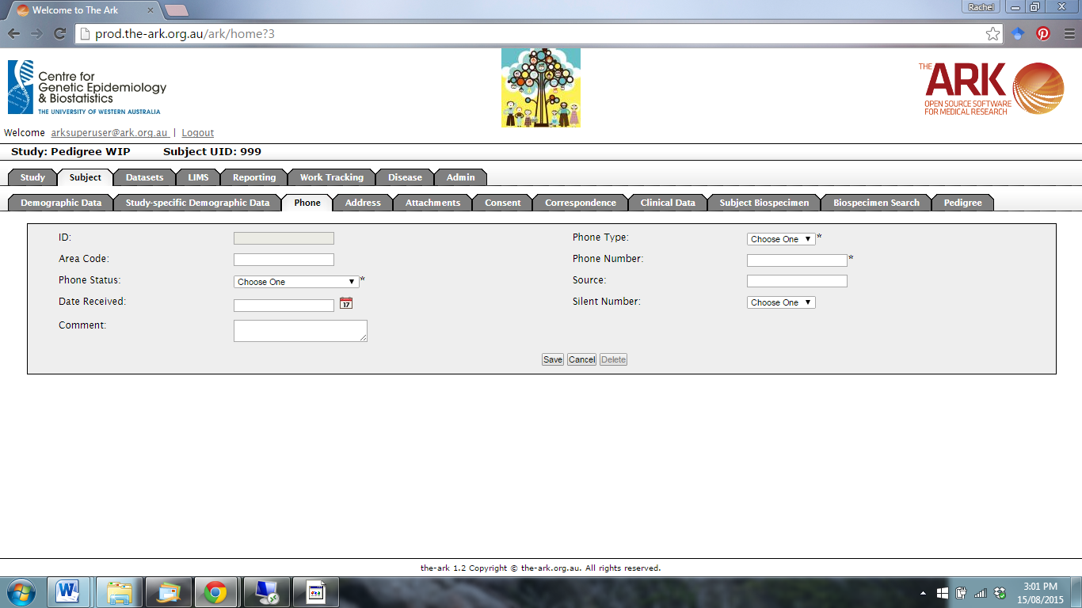

Click on the Address function to add an address.

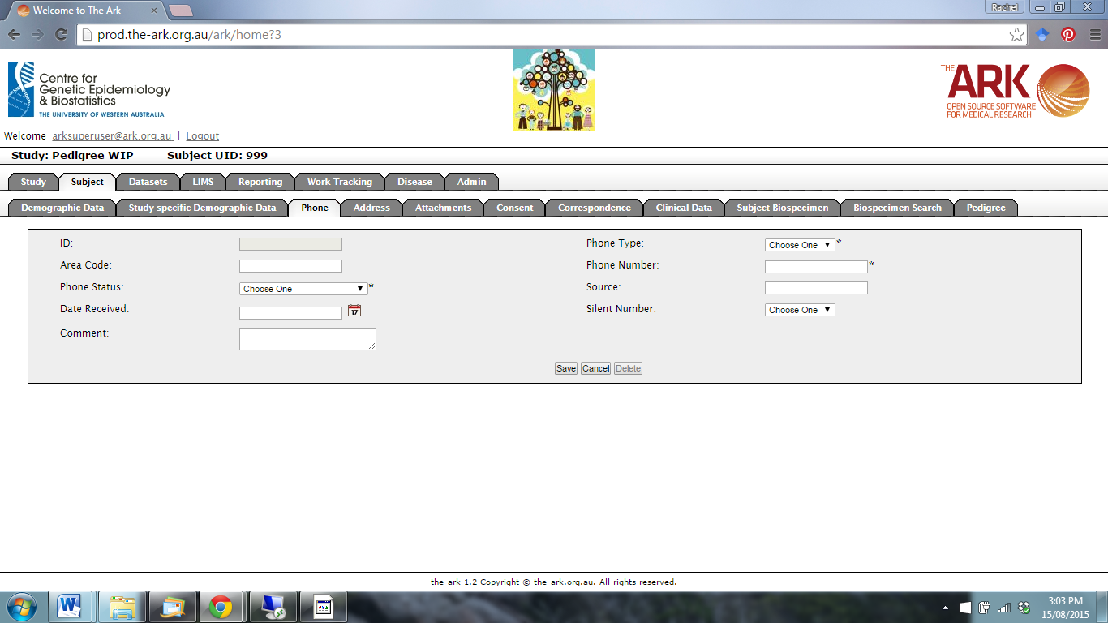

The following page will appear. Click new.

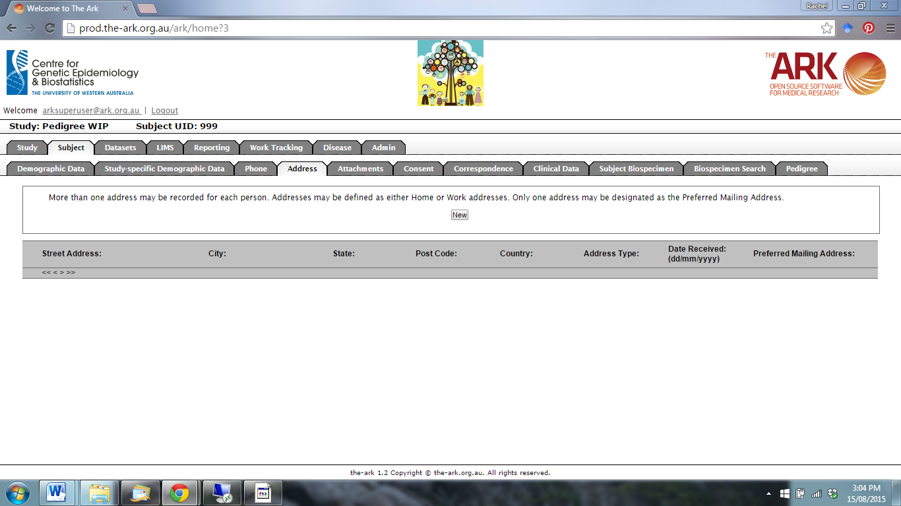

Enter the subject’s address details and click save.

